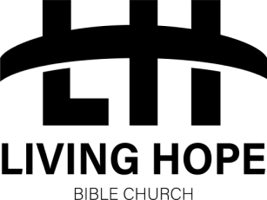

2023
Living Hope Bible Church – LH Senior Youth
Waiver and Medical Release Form – Field Trips and Special Events

Name of Youth_________________________________ Date of Birth_______________

Address:__________________________________________ Parent’s Cell Phone # __________________
Youth Cell Phone #________________ (to text event change)
Other # to reach you or other family members___________________________________

The LH Senior Youth leadership team at the Living Hope Bible Church plan a weekly fun event for everyone in grades 9-12 to attend. These events include games and activities at the church, as well as bus trips to rollerblading, laser tag, concerts, bowling, etc. It is required by our insurance company that we have parental permission for the youth to attend these events. This is a general waiver and medical form which will cover all of the events and activities for September 1, 2023, through September 1, 2024.

Does your child have any severe or life-threatening allergies? (Bee stings, food, penicillin, nuts)
Yes___ No___ If yes, please explain:__________________________________________
Does your child have an Epi-Pen? Yes_______ No______
Is your child taking any medication regularly? (Puffers, Ritalin, etc)
Yes___ No ___
If yes please explain:____________________________________
________________________________________________________________________

Precautions are taken for the safety and health of your child, but in the event of an accident or sickness the Living Hope Bible Church, its staff and volunteers are hereby released from any liability. In the event that your child requires special medication, x-rays or treatment, the parents/guardians will be notified immediately.

I hereby authorize the staff and volunteers at Living Hope Bible Church to take video and still pictures of my child during Youth. These videos and still pictures may be used on Living Hope’s website, marketing material, YouTube and Facebook promotions. I understand they retain the sole right to use photos and video for publicity and advertising purposes. Yes ___ No ___

I give consent for the Youth Pastor and male or female youth leaders to contact my son or daughter via group texting or calling for the sake of discipleship, encouragement and or general discussion under the condition of complete transparency at the request of the parent/legal guardian. Yes ___ No ___

I give permission for my child to attend and participate in the events and activities planned by the Living Hope Bible Church Youth Group. I understand that if my child is disobedient or disruptive, I will be notified to come and pick up my child from the event at my own expense.

____________________________ _______________________
Parent/Guardian’s Signature Date

